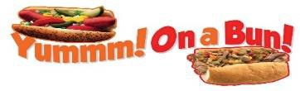
Chicago’s Taste & More – Mobile Food Truck
www.chicagostasteandmore.com 817-899- 6193
Authentic Vienna Beef Products
All menu items may not be served at each event or location

Dogs & Polish served on poppy seed bun or plain bun
Chicago Style Hot Dog  Chicago Style Jumbo Dog  mustard, relish, tomato, kosher pickle, sport peppers, onions  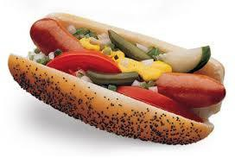 | Chicago Style Polish  mustard, relish, tomato, kosher pickle, sport peppers, onions  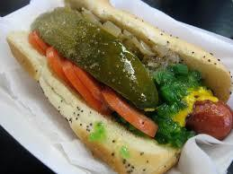 | Chili Cheese Dog  Jumbo Chili Cheese  onions, mustard  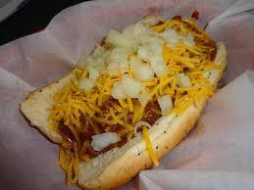

Deep Fried Dogs (mustard, grilled onions, sport peppers)
Char Dog  Jumbo Char Dog  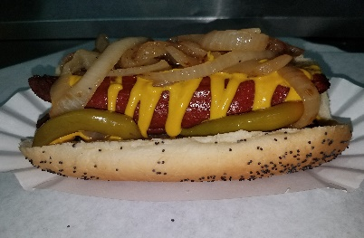 | Maxwell (Polish Sausage  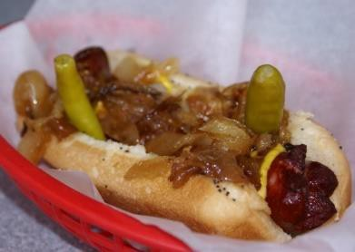
Spicy Dog  mustard, grilled vienna dog, grill onions, giardiniera peppers  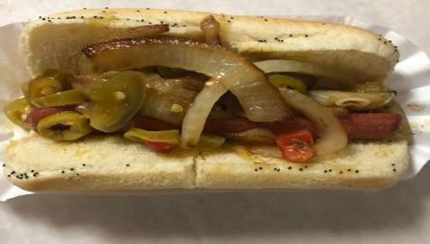 | New York Style Dog  vienna dog, spicy mustard, grilled onions, sauerkraut celery salt upon request  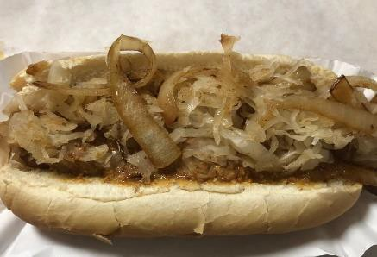
Sandwiches (roll dipped or dry)
On Turano roll with either Giardiniera (hot peppers) or (sweet) Bell peppers
Italian Beef  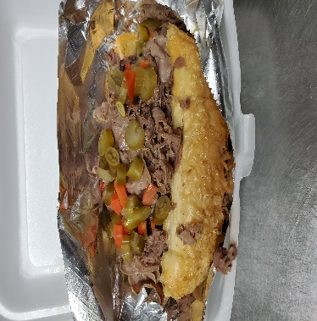 | Cheezy Beef  Mozz or Cheddar Cheese  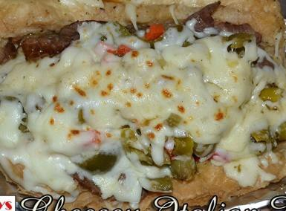 | Chicago Philly Beef  Italian beef, mozzarella cheese, bell peppers,  grilled onions  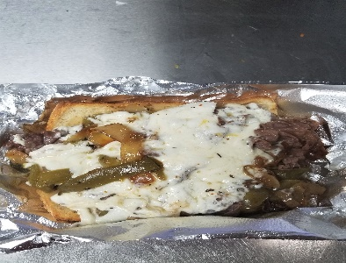
Italian Sausage  Mustard or Marinara,  grilled onions  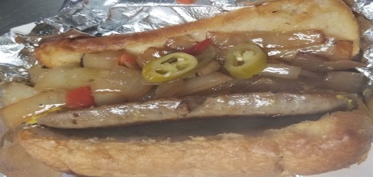 | Italian Combo  Italian Beef & Sausage  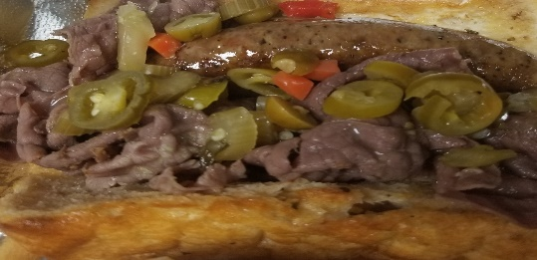

More Choices

 | Spicy Chicken Hoagie  Lettuce, tomato, spicy ranch  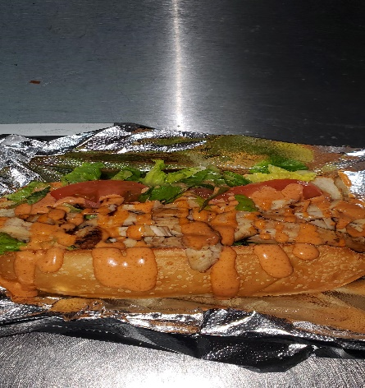 | Gyro  Tomatoes, onions, tzatziki sauce on pita bread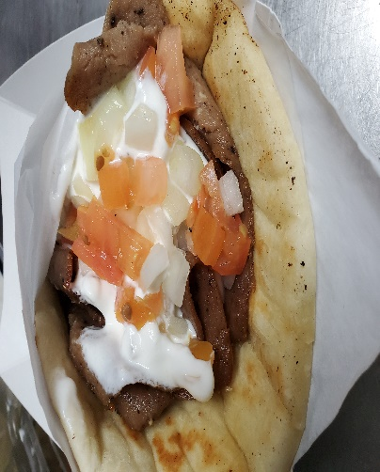 | Philly Cheese Steak  On hoagie, swiss cheese, bell peppers, grilled onions  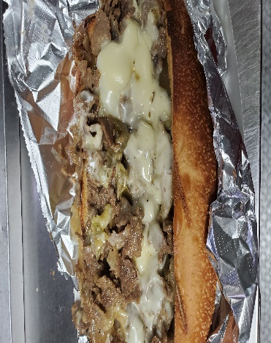

 | Loaded Chicken Fries  Diced chicken, cheese sauce, ranch, bacon, chives  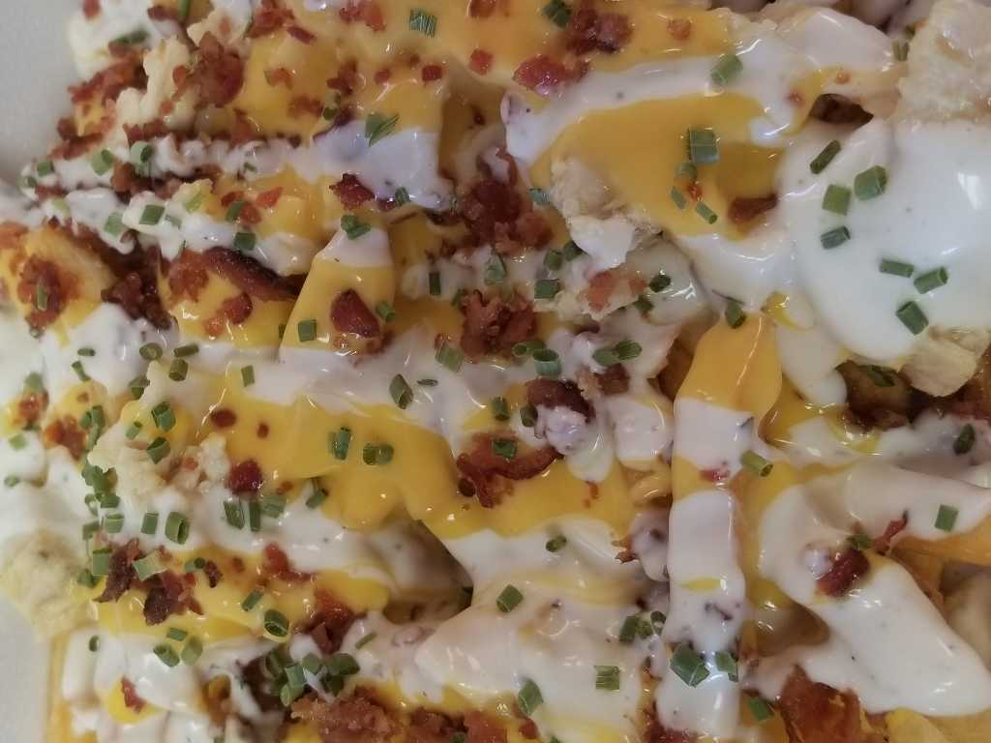 | Philly Chicken  On hoagie, grilled chicken, swiss cheese, bell peppers, grilled onions  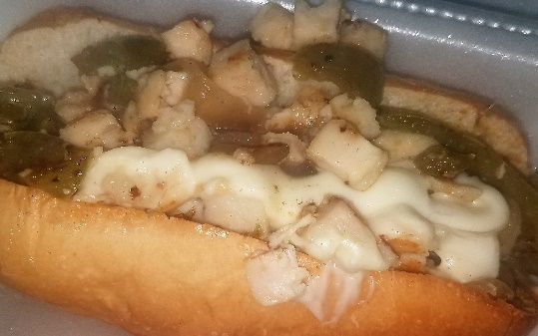 | Veggie Hoagie  hoagie bun, swiss cheese, grilled onion, bell pepper & tomato, lettuce  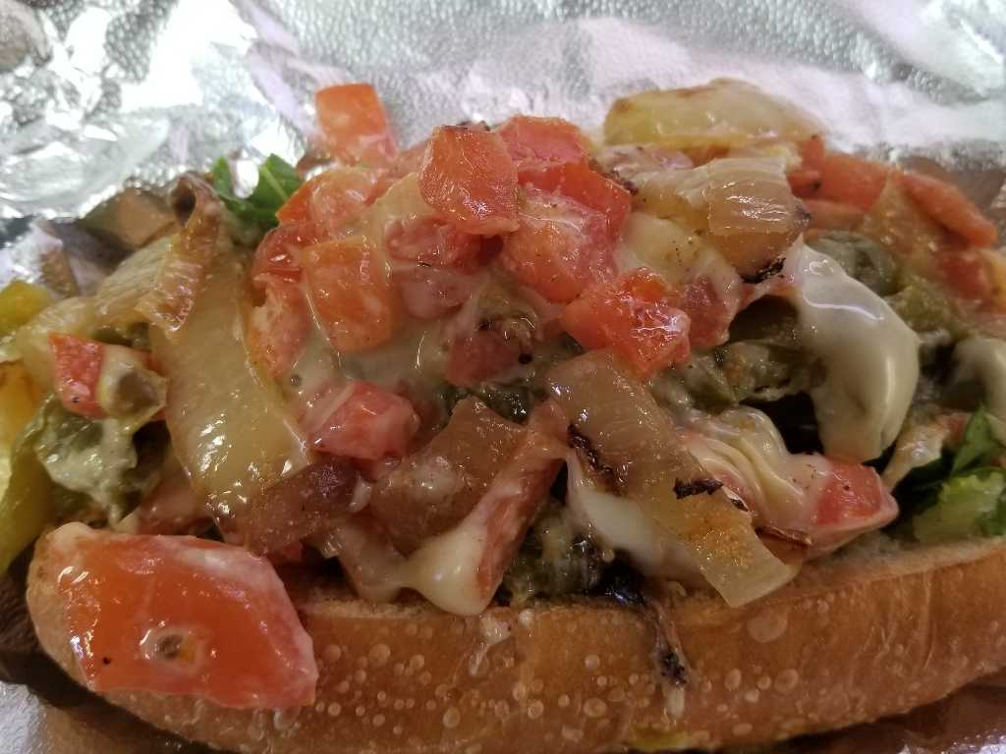

Fries  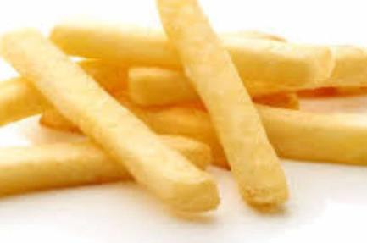  Cajun Fries  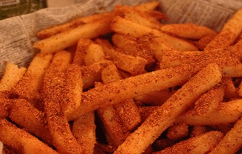 | Sweet Potato Fries With sirarachi dipping  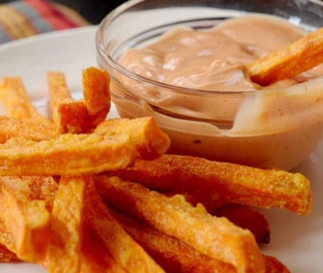 | Curly Fries  With ketchup  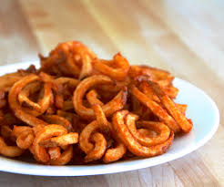 | Garlic Parmesan Fries (or)  Garlic Parm Tots  With spicy ranch  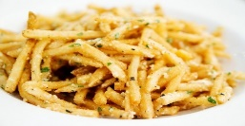  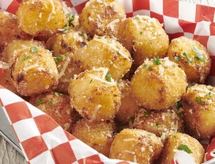

Chili cheese Fries  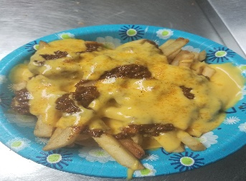  Chili cheese tots  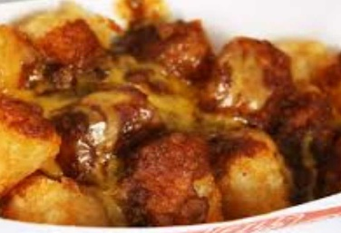 | Lemon Pepper Fry  (reg or spicy ranch)  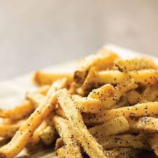 | Loaded Bomber Fries  Cheese sauce, bacon, chives, ranch  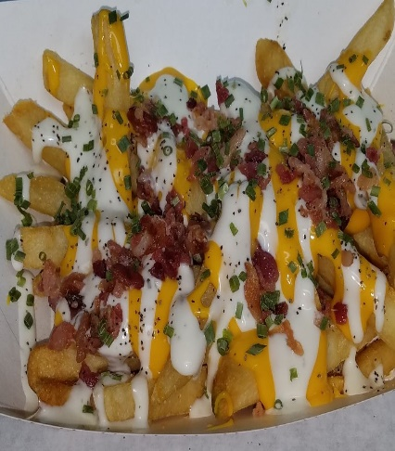 | Loaded Tator Tots  Cheese sauce, bacon, chives, ranch  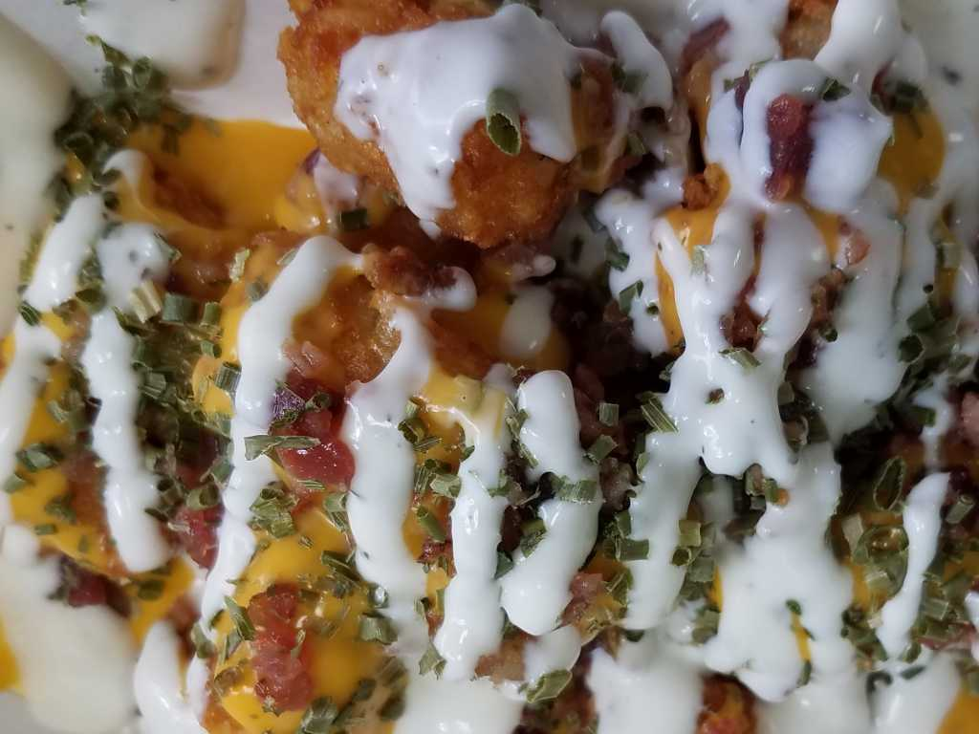
Bottle Drinks
Coke, Sprite, Diet Coke, Dr Pepper, Big Red
Water, Unsweet or Sweet Tea, Powerade,
Fruit Punch or Lemonade

view menu served at each location visit: https://app.getyomojo.com/order?vendor=mLFasOKBpx

Items that served at some events

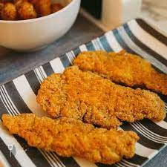 | 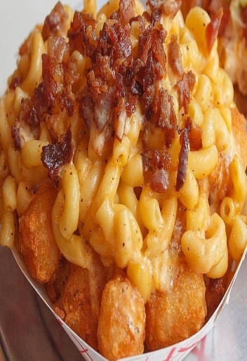 |  | 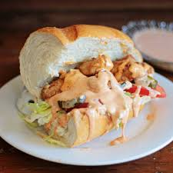 |  | 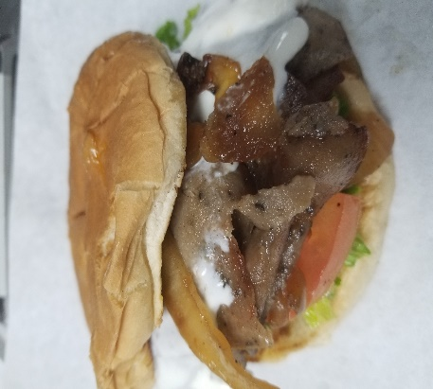
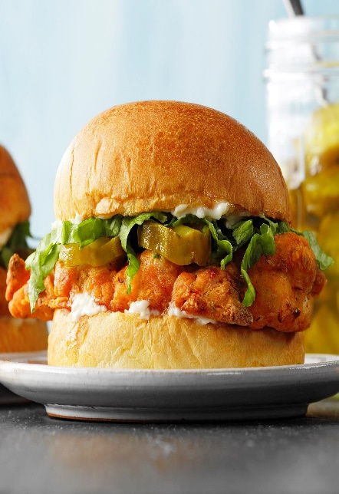 |  | 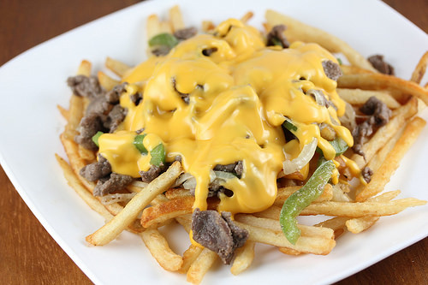 |  | 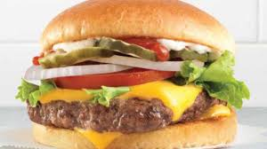 | 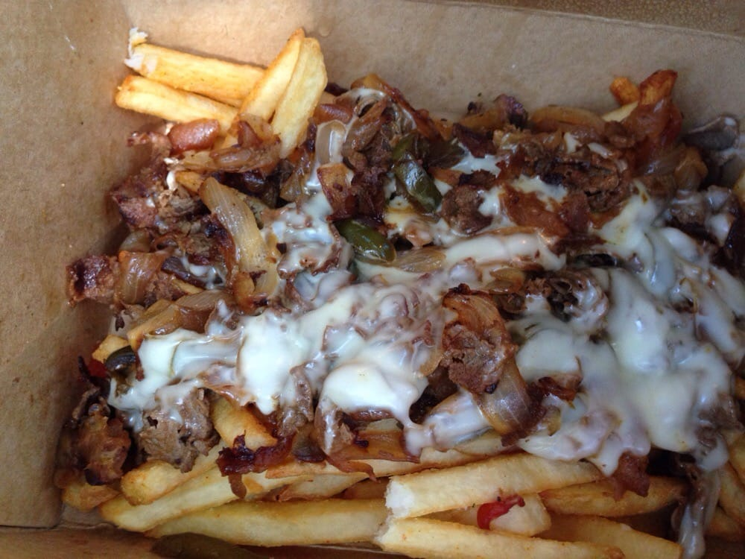

Let us cater your next special event
chicagostasteandmore@gmail.com

